Experiment1:

Establish an AWS account. Use the Management console to launch an EC2 instance and connect to it(use pem and ppk )

Using pem

Step 1:login into your aws account and start the lab.

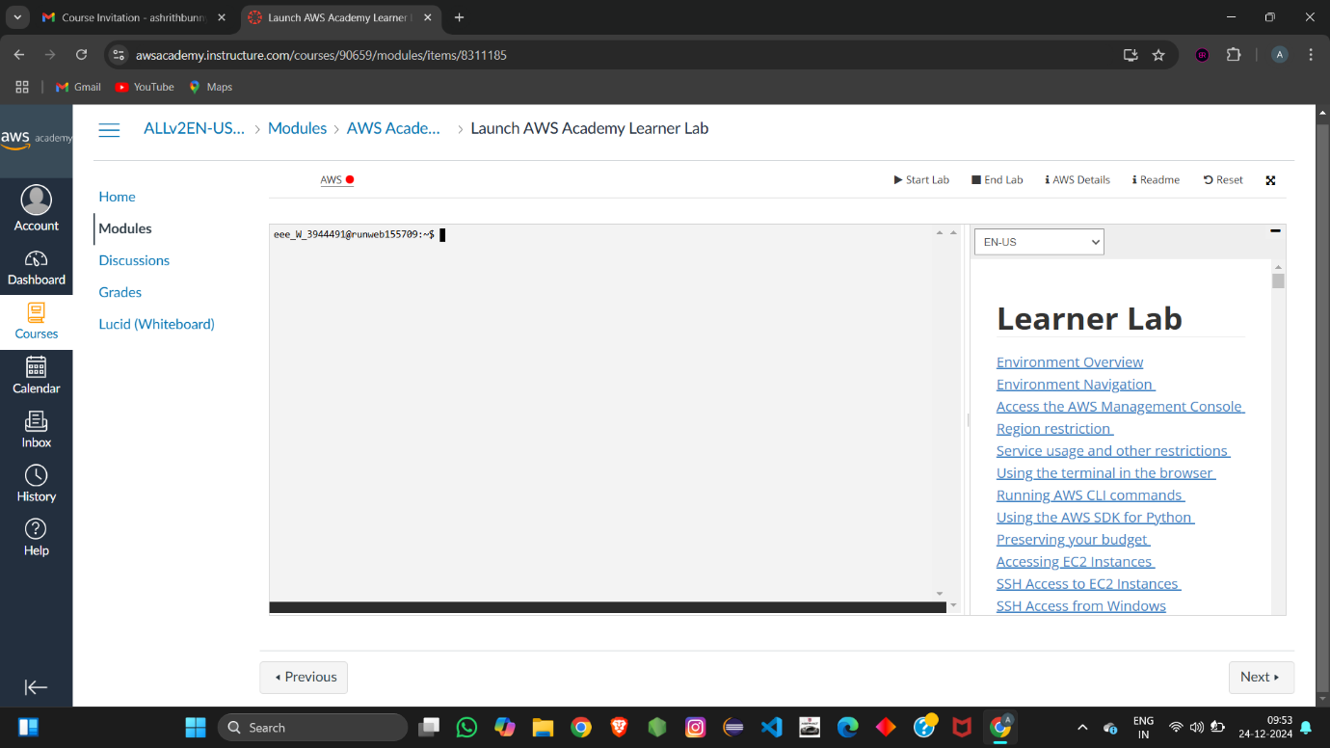

Step 2:click on aws and click on EC2.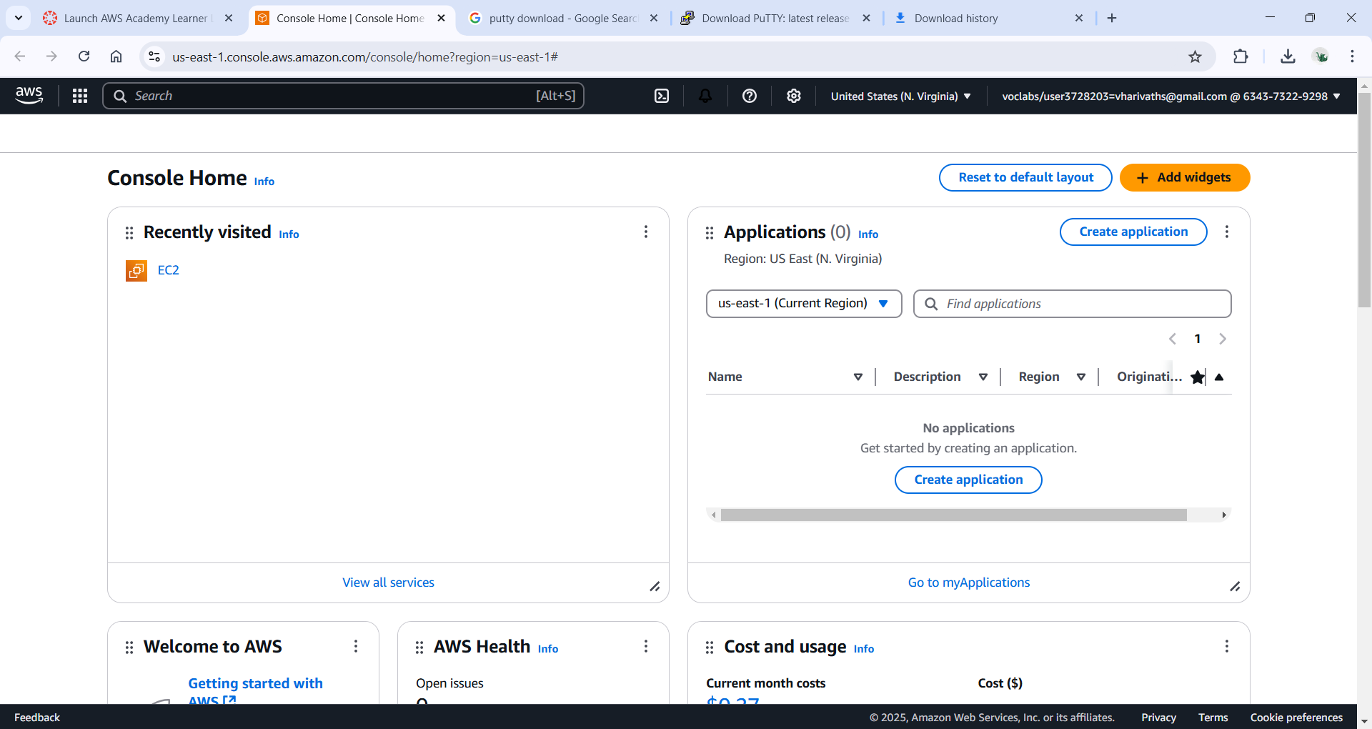

Step 3:click on launch instance

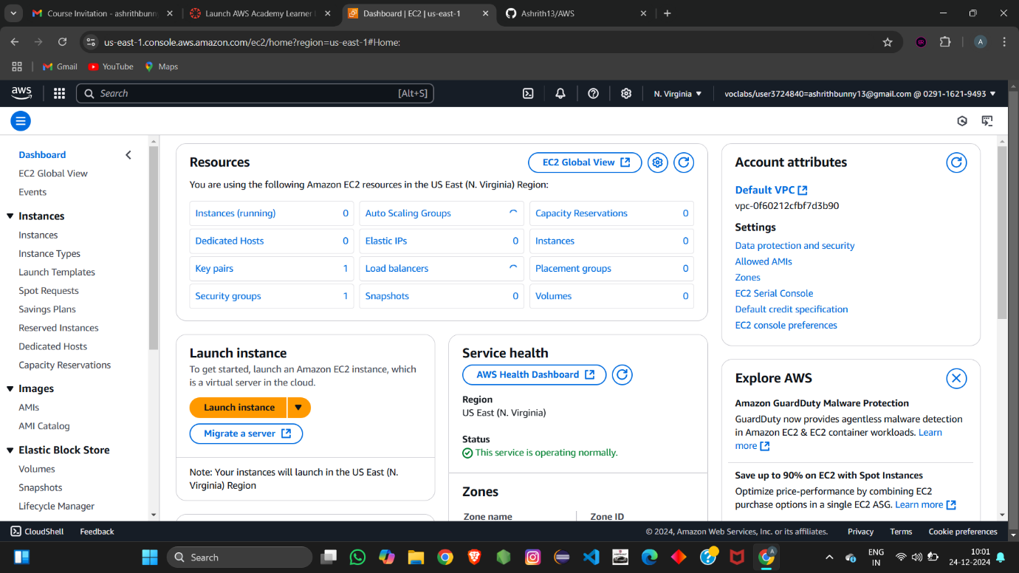

Step 4: Now, name the instance and select the OS image

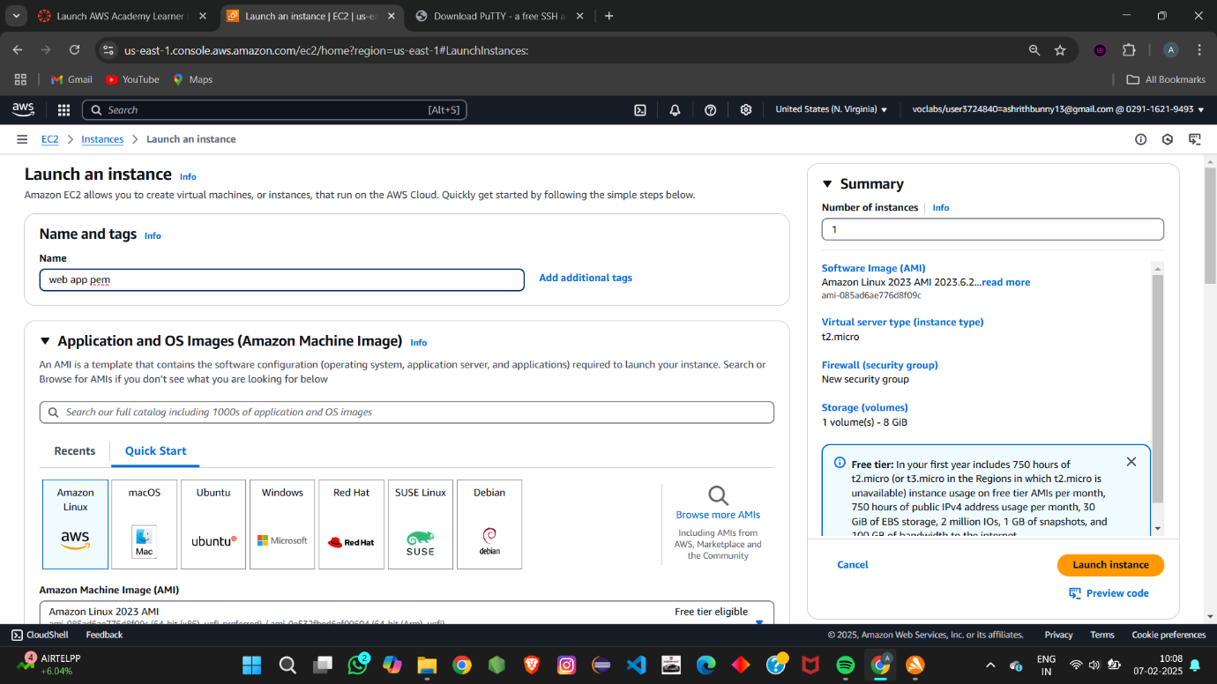

Step 5:Now select the instance type you want.

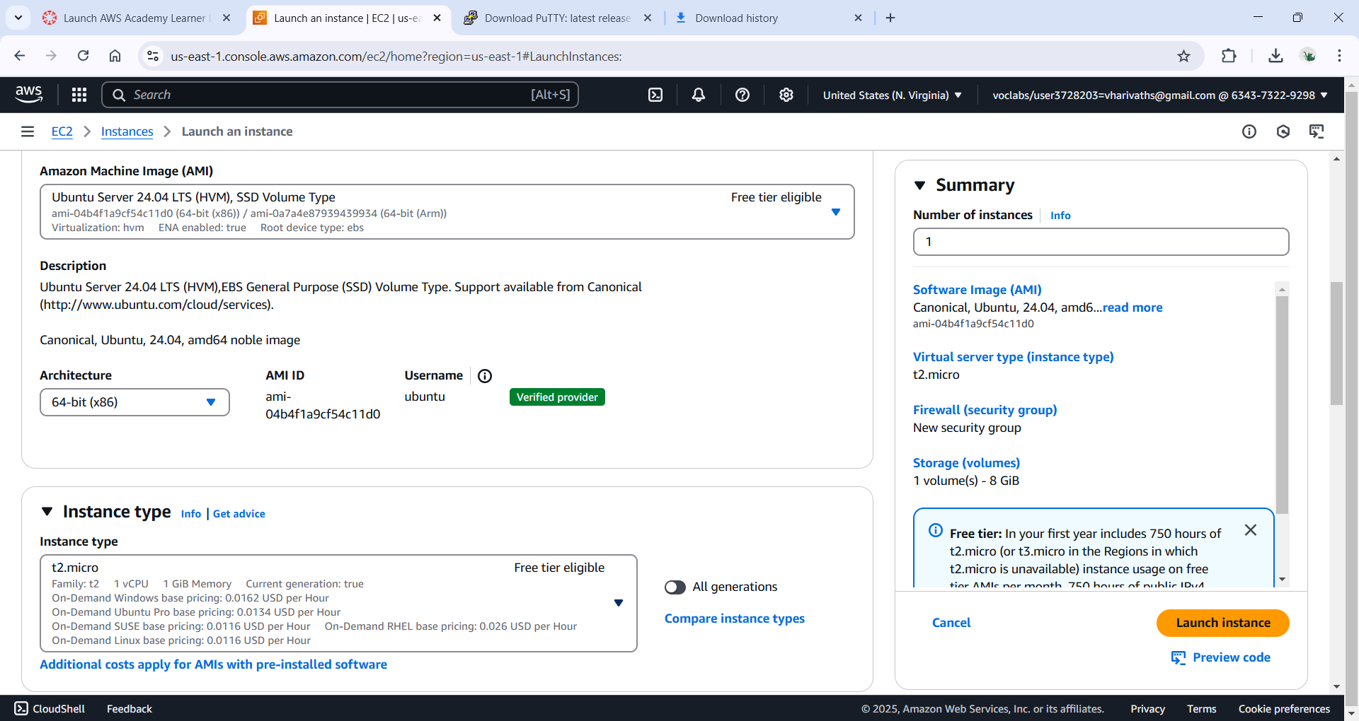

Step 6:Now create and key pair using pem file formate

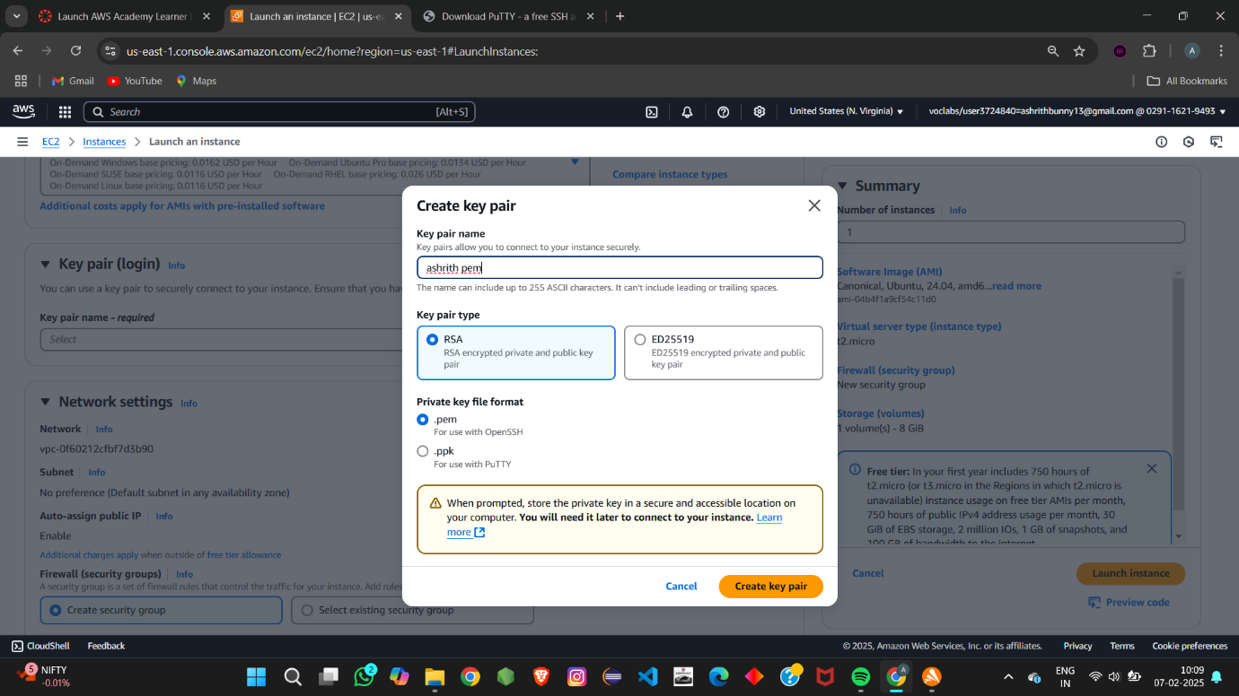

Step 7: Now select or allow all firewall option.

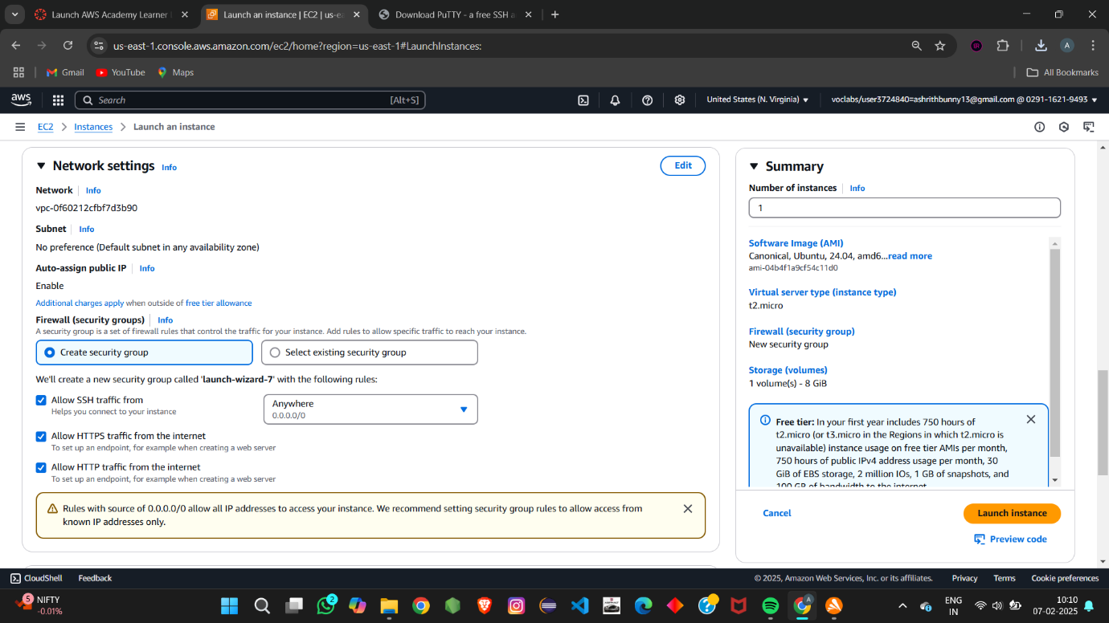

Step 8: click on launch instance.

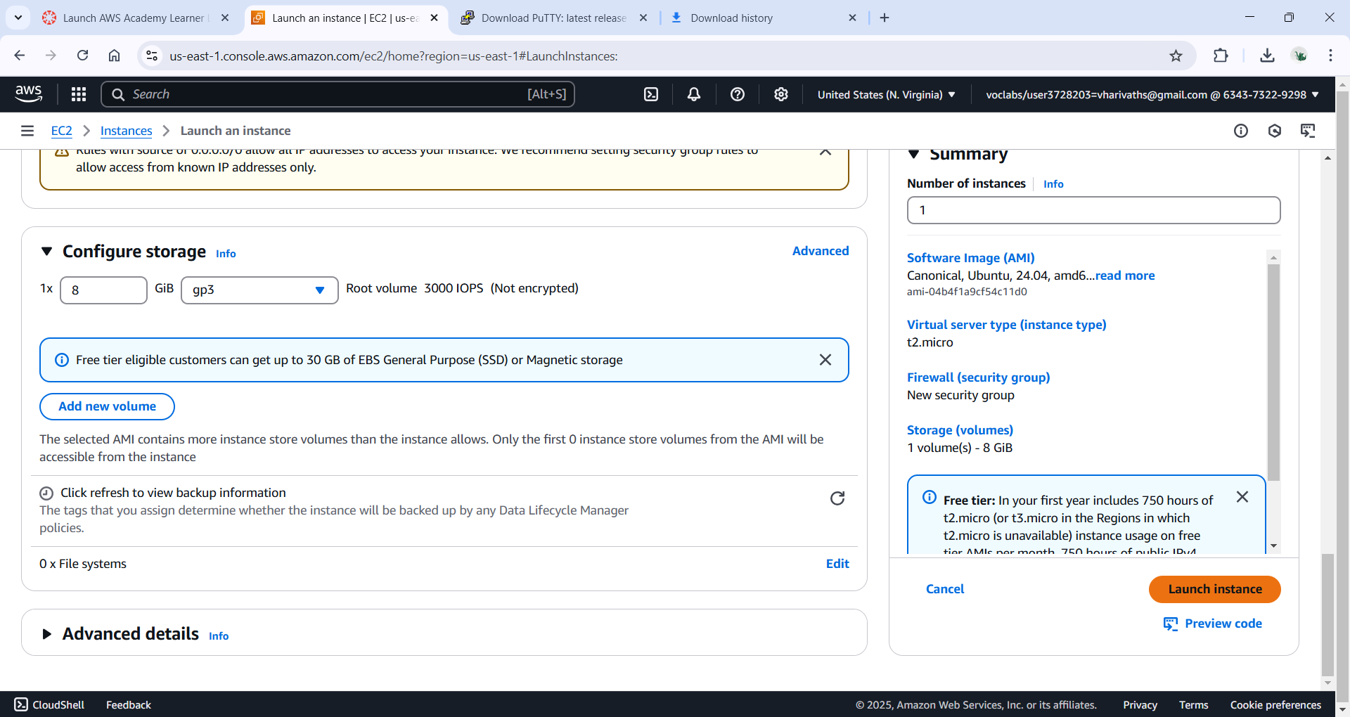

Step 9:Now wait for the instance to load and then click on link

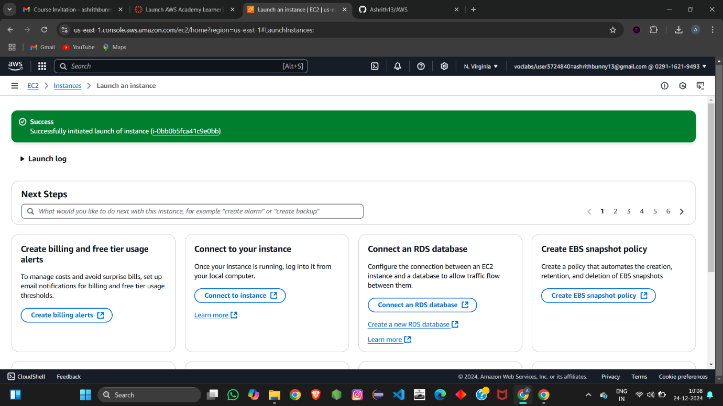

Step 10: select the instance and connect and here we connect it in two ways

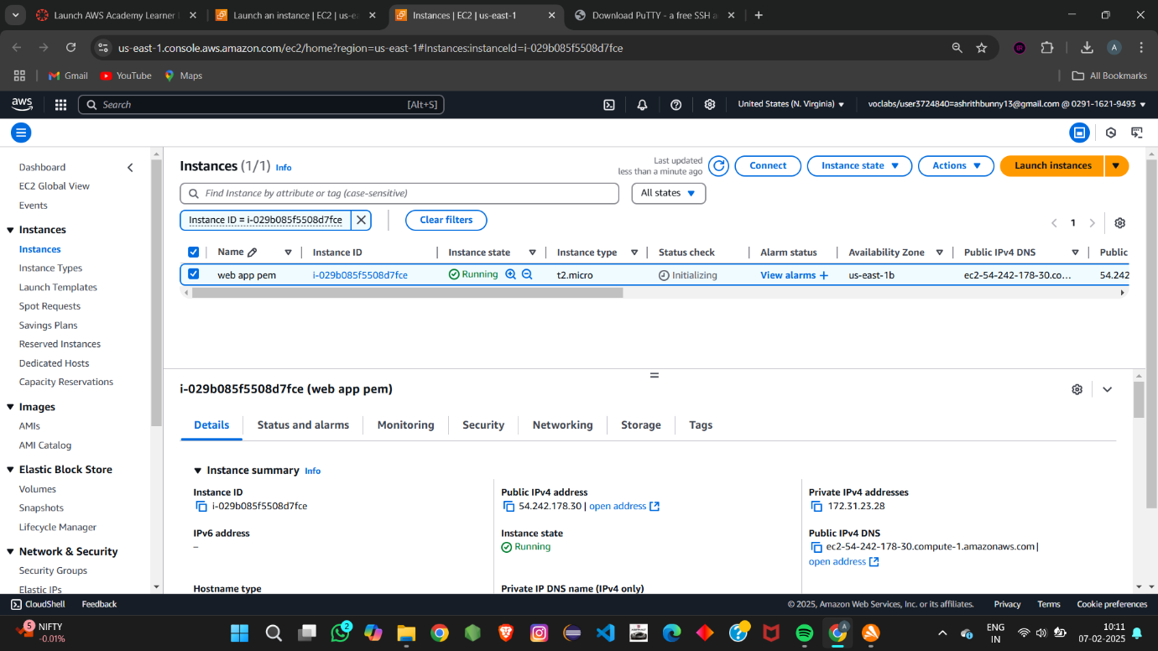

Step 11: 1st way select EC2 instance Connect and click on connect



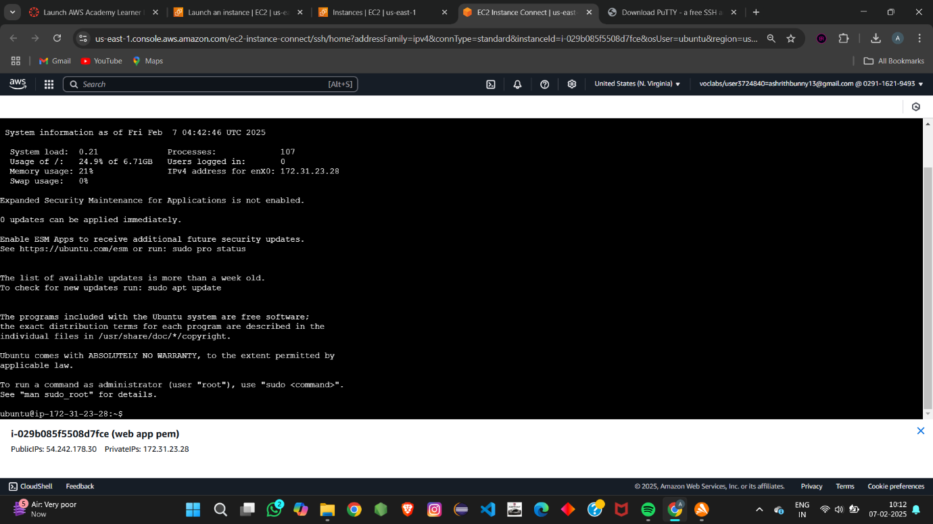

Step 12: 2nd way select ssh client and open git bash int the folder you have kept the pem key and type the command ( ssh -i "webpem.pem" ubuntu@ec2-54-90-122-203.compute-1.amazonaws.com)

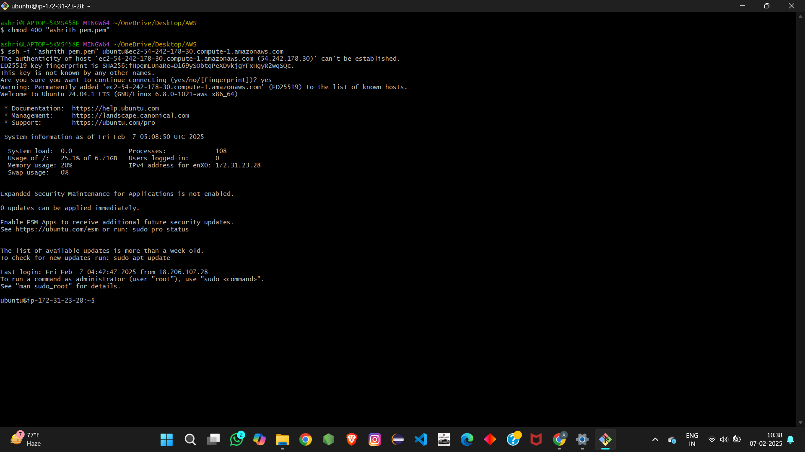

using ppk

Step 1: click on launch instance and name the instance and select the OS image

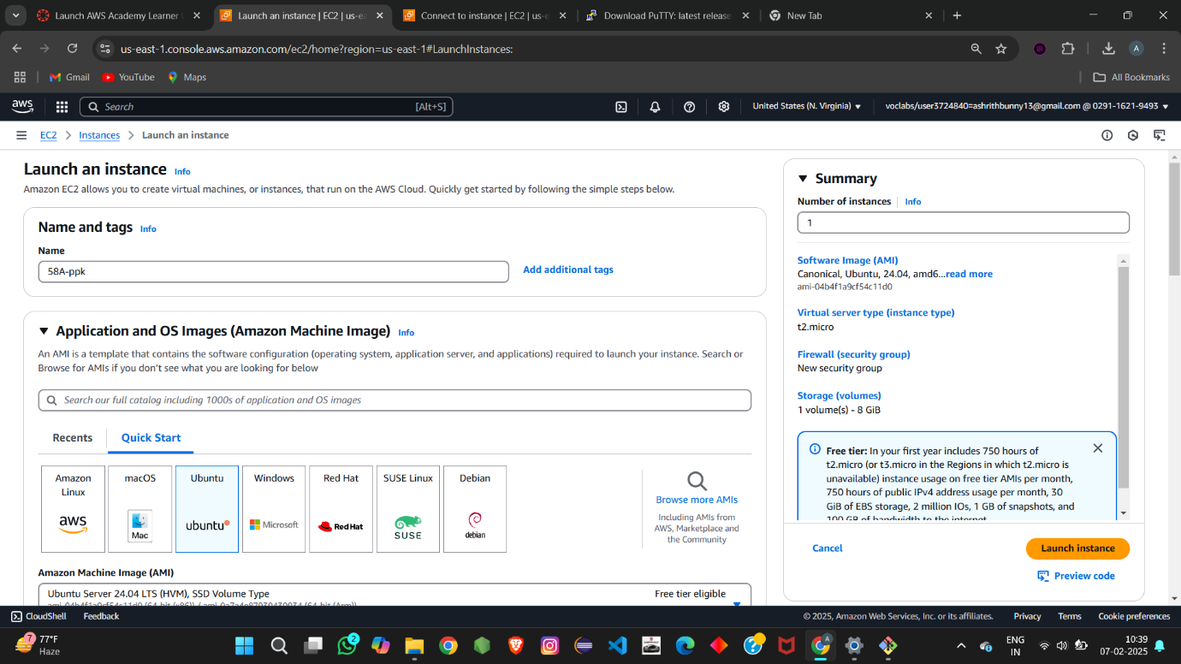

Step 2: Now create and key pair using ppk file formate

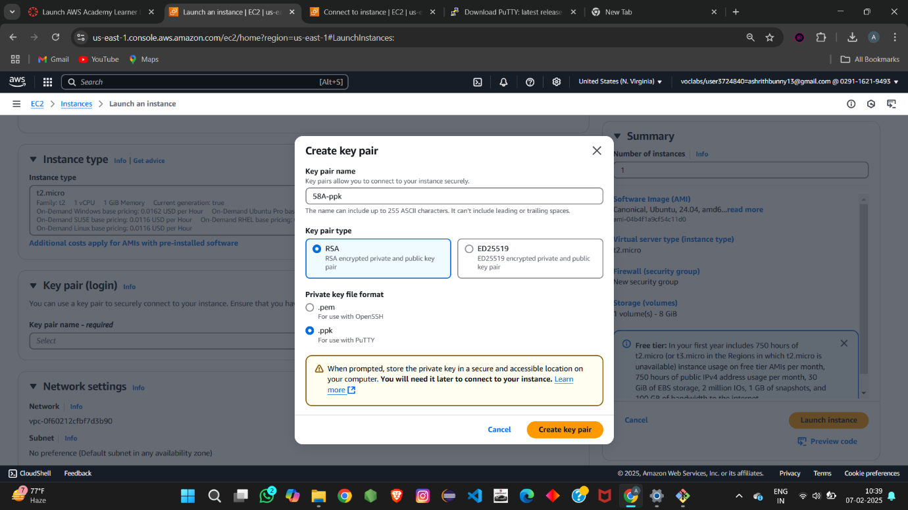

Step 3: Now select or allow all firewall option.

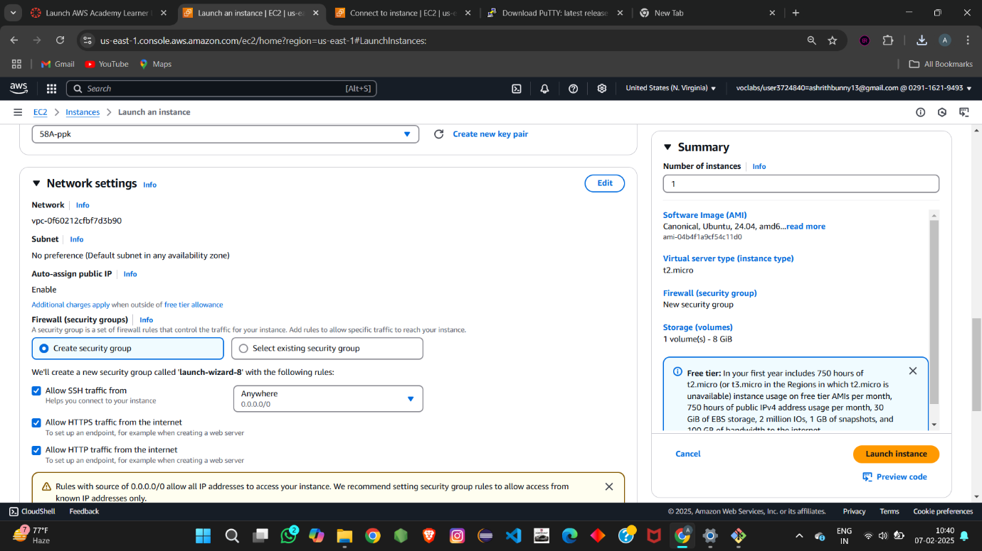

Step 4: click on launch instance and Now wait for the instance to load and then click on link

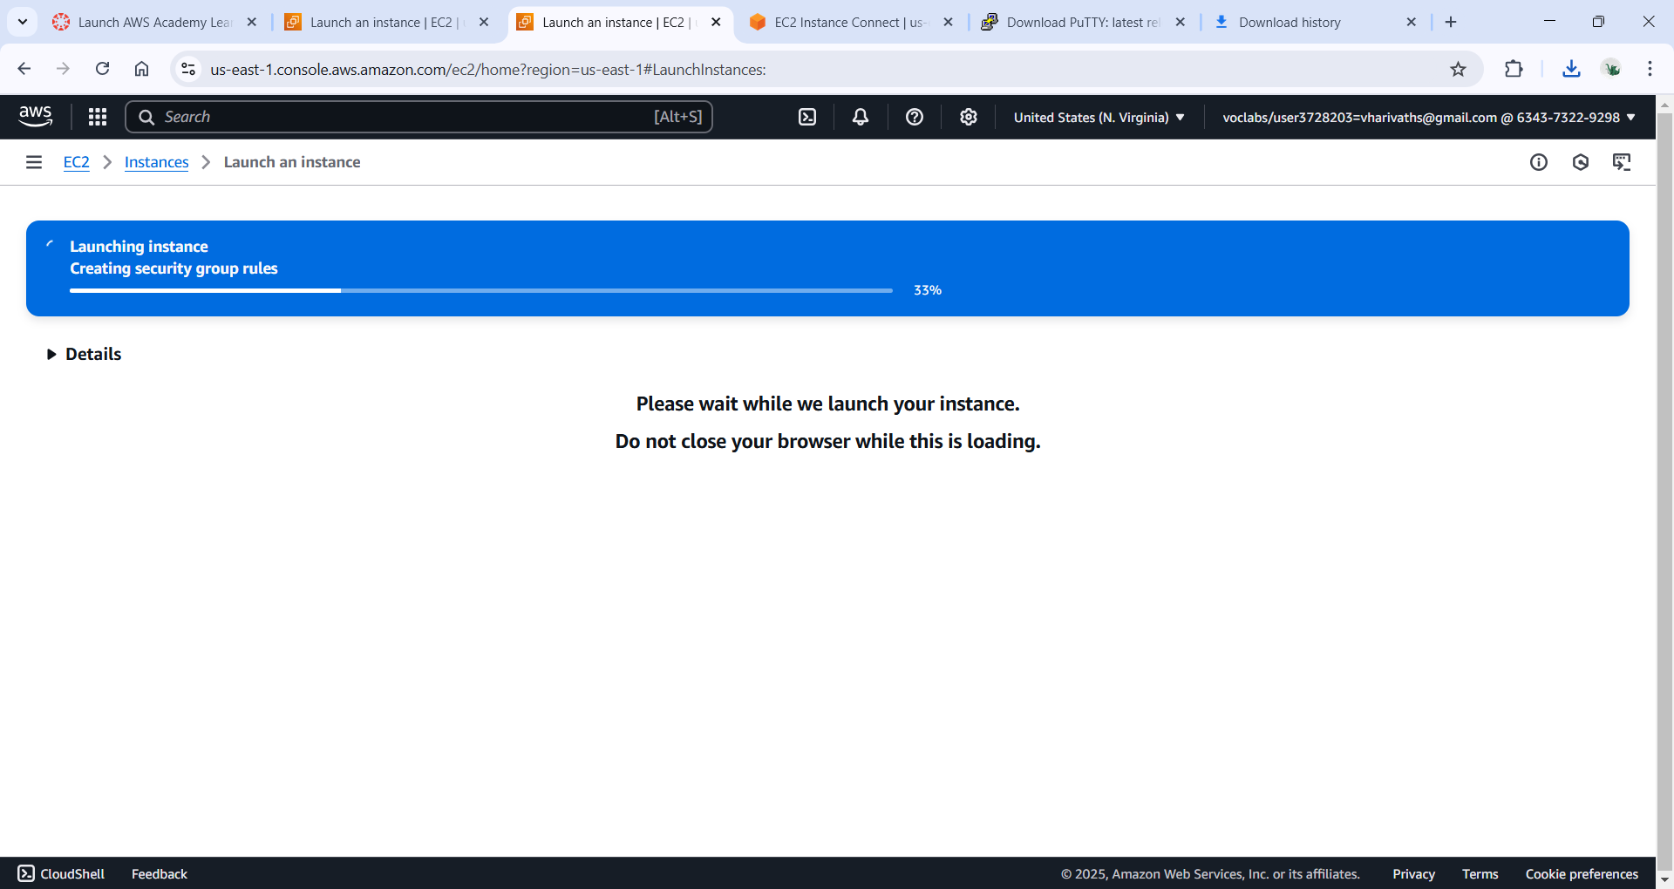



Step 5: select the instance and connect and here we connect it in two ways

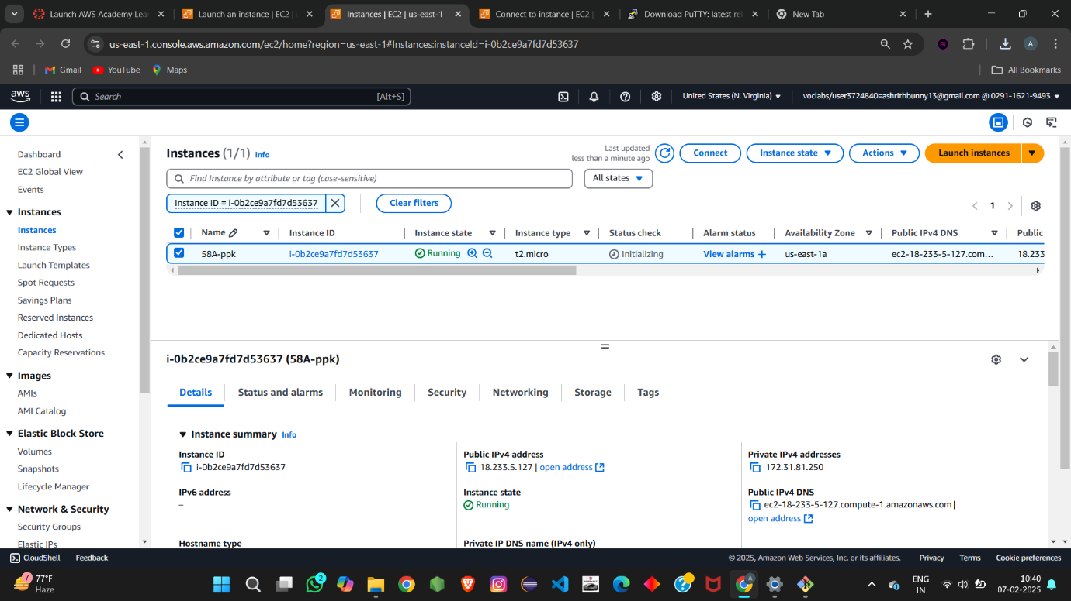

Step 6: 1st way select EC2 instance Connect and click on connect

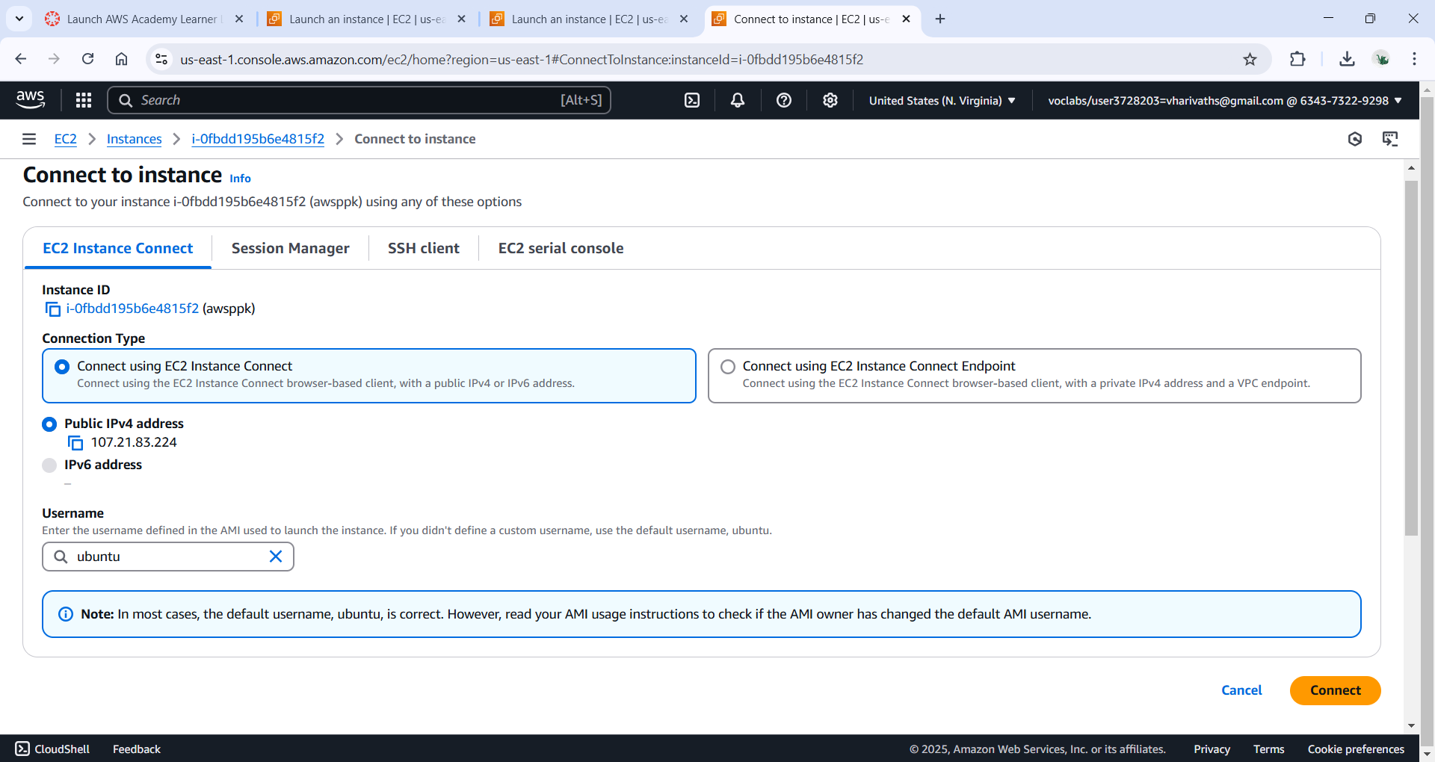

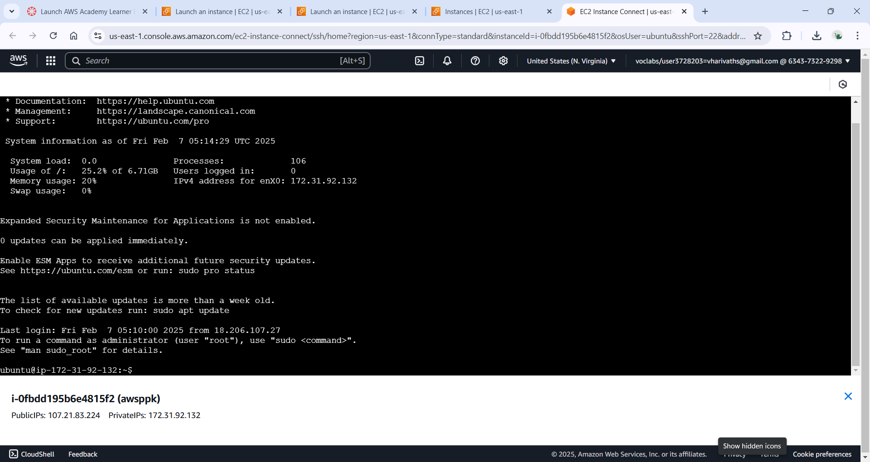

Step 7: 2nd way is using putty so first go to google and search putty download

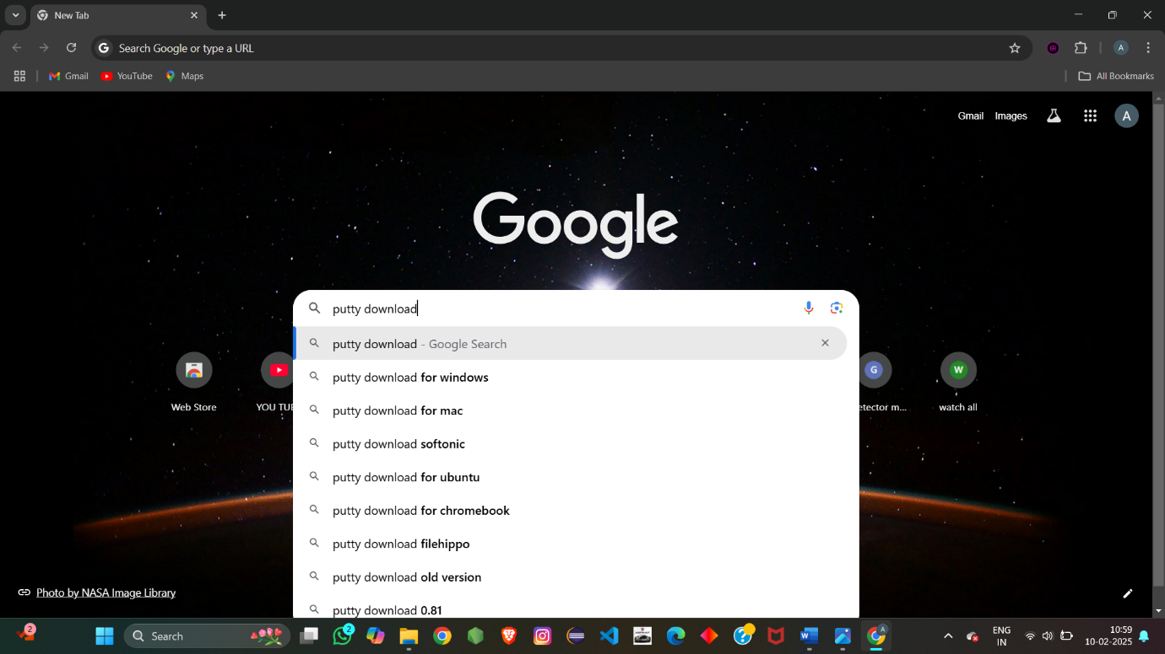

Step 8: click on first link

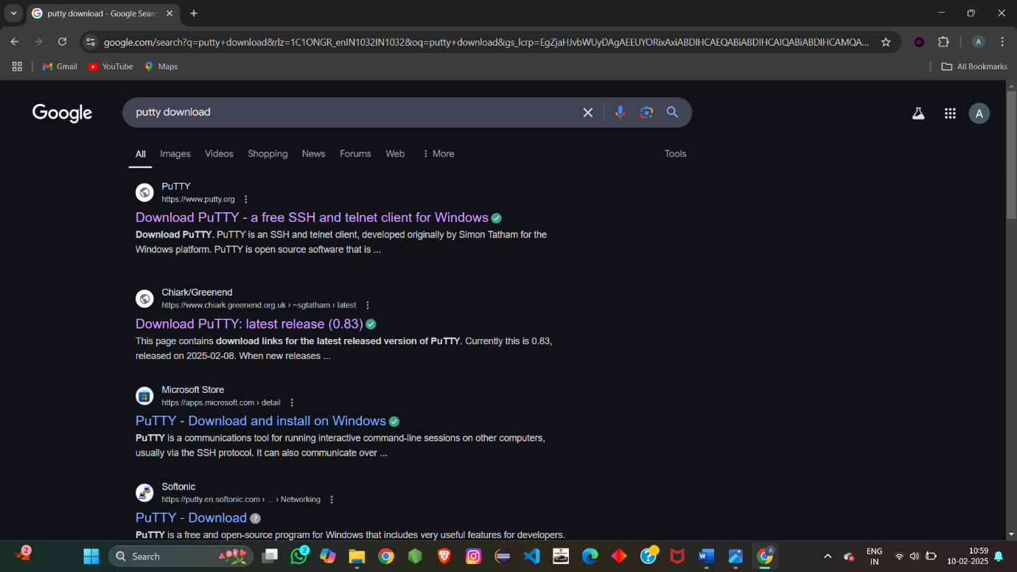

Step 9: click on Download PuTTY

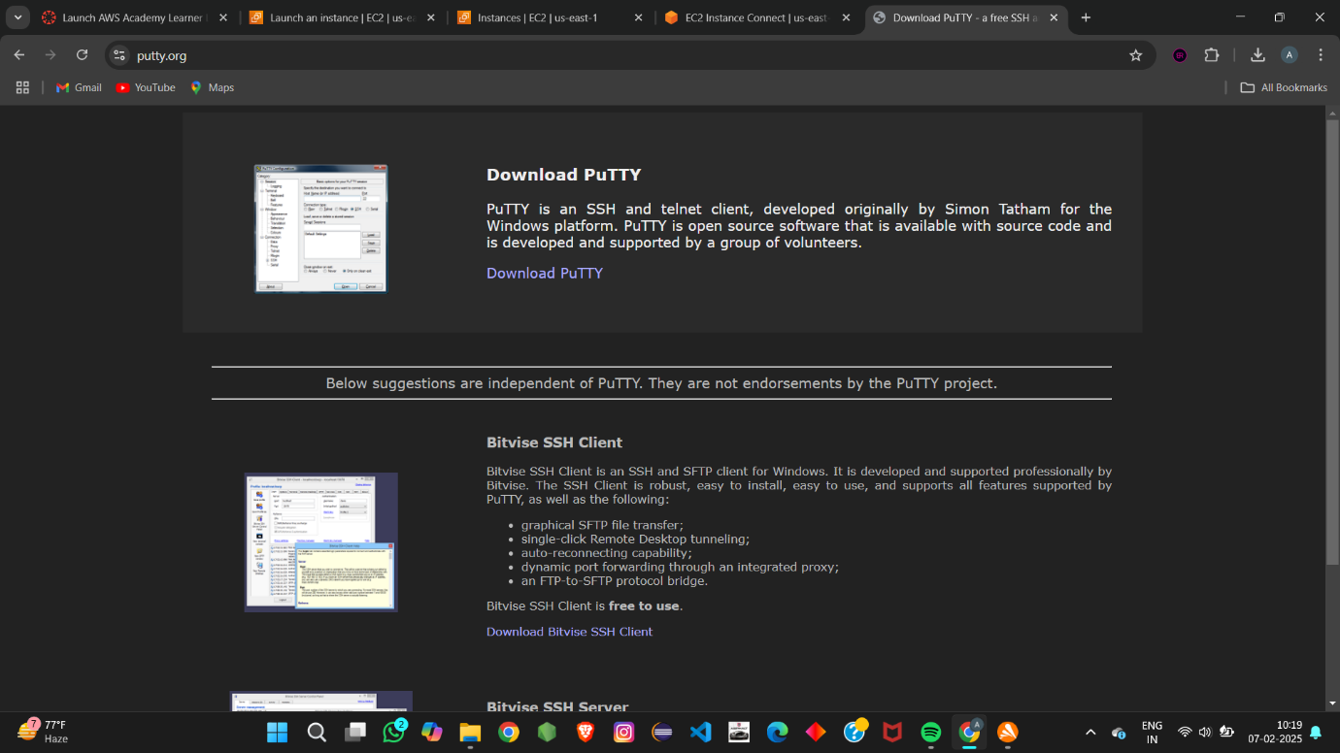

Step 10: go to Alternative binary files and select 64-bit x86 putty.exe to download.

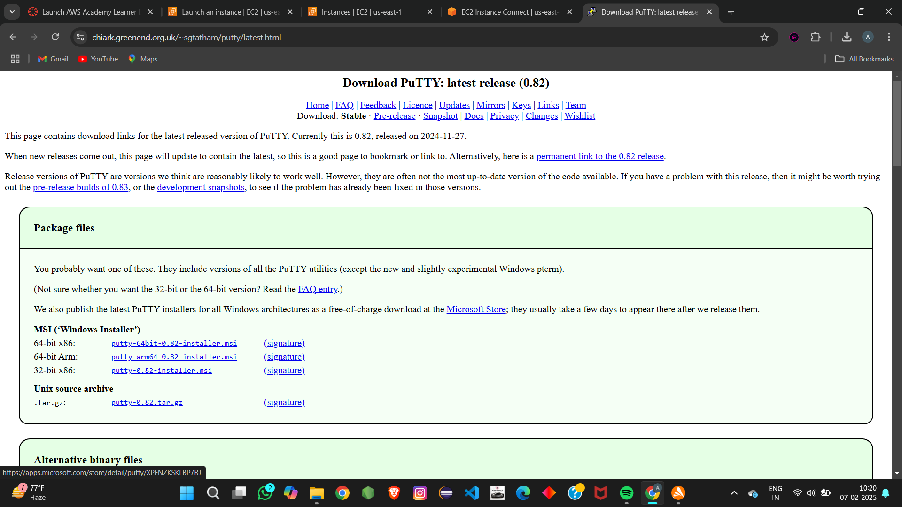

Step 11:open putty terminal.

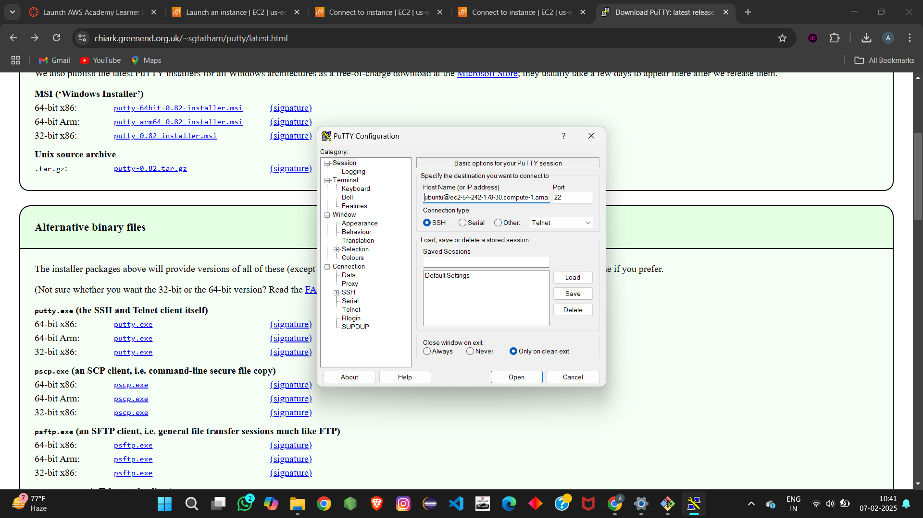

Step 12:add the hostname and select SHH->Auth->Credentails

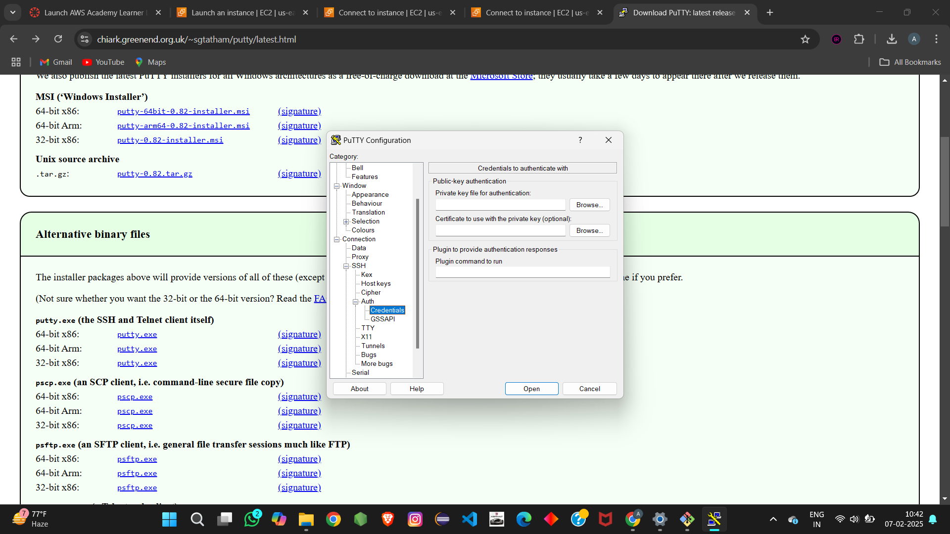

Step 13:Now, select private key file

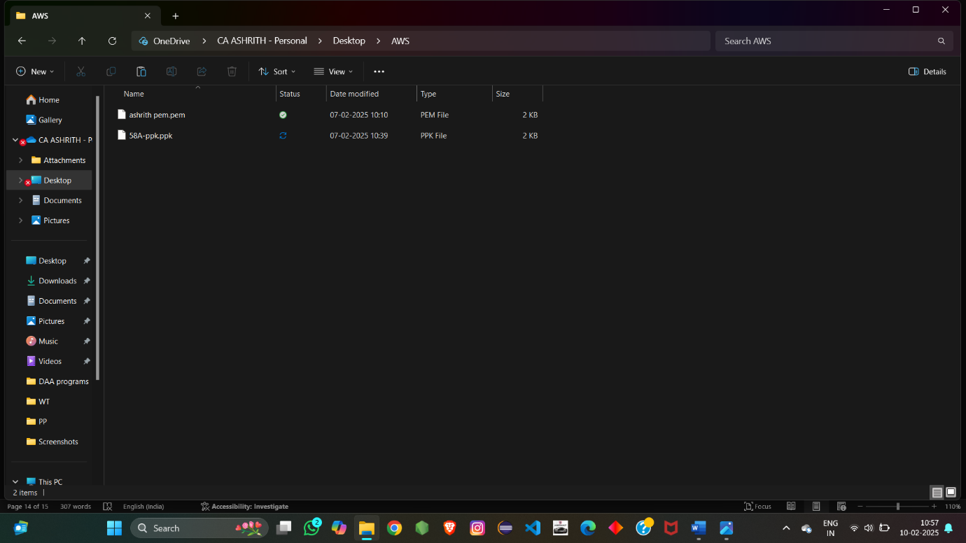

Step 14:click on open .

